A User’s Guide to the Central Portal of
the Biosafety Clearing House
“Using the BCH Modules to
Meet Stakeholder Needs”

July 2008

Module Outline

1. Introduction to the Module 3
1.1 Context 3
1.2 Audience 3
1.3 Purpose 3
2. Using the BCH Training Modules 4
2.1. About the Users’s Guide 4
2.2. BCH Users and Stakeholders 4
2.3. Addressing Different Stakeholders Needs 4
3. Available Resources 5
3.1. Training Modules 5
3.2. Interactive Modules 6
3.3. Case Studies 7
3.4. Ready Reference Guide 8
3.5. Discussion Points with Answer Keys 8
3.6. Quiz Questions with answer Keys 9
3.7. Operational Handbook 9
3.8. Promotional Material 9
3.9. Exercises 10
3.10. Hermes BCH Development tool 10
3.11. Ajax BCH Development tool 10

- Introduction to the Module

Context
The UNEP-GEF Project for Capacity Building for Effective Participation in the Biosafety Clearing House (BCH) is preparing a modular training package that aims to provide a practical “how-to” guide for countries to assist them in learning, understanding, using, and setting-up national access to the BCH. The training package is designed to be flexible and is tailored to meet diverse needs of different countries, allowing them to select those tools and ideas that are most useful to their situation, needs and priorities. The training package is divided into four modules, each addressing one element of the Biosafety Clearing House (BCH).

Audience
This module is designed to provide guidance to instructors using the BCH Training Modules to train a variety of different stakeholders.

Purpose
The BCH Modules comprise a set of cohesive training subunits. The training subunits are selfcontained, which means that different components can be put together in various formats suitable for different target audiences.

Please note that the following curricula are intended as a guide to identify topics of greatest interest only, and should not in any way be interpreted as exclusionary. Subunits should be added or deleted according to the prior experience of participants and the time available for training.

- Using the BCH Training Modules

 | OVERVIEW  The BCH User’s Guide is a modular suite of complementary tools that can be combines in different sets according to the training needs and interest of the users

About the Users’s Guide
The User’s Guide to the Central Portal of the Biosafety Clearing House has been developed as part of the UNEP-GEF Project for Capacity Building for Effective Participation in the Biosafety Clearing House (BCH) to provide a practical “how-to” guide for the different users of the BCH to assist them in using the BCH.
The Guide contains a suite of training tools presented in a modular training package that cover all aspects of using the BCH, including accessing information, registering information, sharing information, and setting-up national access to the BCH. The training package is designed to flexible and is tailored to meet diverse needs of different countries and stakeholders, allowing them to select those tools and ideas that are most useful to their situation, needs and priorities.

The User’s Guide comprises multiple modules (including this one), each addressing a different element of the BCH. Additional tools for trainers are provided in one Appendix to the Guide.

BCH Users and Stakeholders
The BCH assists Parties to the Protocol and other stakeholders in different ways in the implementation of the Protocol. It functions like a central information marketplace, where the producers and users of biosafety information interact and exchange that information in a transparent manner.
The BCH is the key for governments to access information they need to make and share informed decisions regarding the import or release of living modified organisms (LMOs). The BCH contains information that Parties have to provide (such as national contacts, relevant laws and regulations, and decisions on release and import) as well as other information and resources relevant to implementing the Protocol, such as information on capacity-building, access to experts, links to biosafety resources, organizations, academic courses and other information exchange mechanism. Governments that are not Party to the Protocol are also encouraged to contribute information to the BCH.
By allowing easy and open access to key information, the BCH fosters greater transparency in the implementation of the Protocol and this facilitates effective participation of the public and civil society groups in the decision-making process.
The BCH also facilitates scientific and technical cooperation between Parties and other relevant stakeholders, for example by allowing interested stakeholders to access or contribute information on existing biosafety capacity building activities in addition to countries registering their capacity building needs and priorities, thus facilitating coordination and synergy between various initiatives.
For industry, researchers and other stakeholders the BCH allows easy access to information vital to their activities, including details of the national contacts, relevant legislation and agreements, and the decisions and declarations that govern LMO activities and movements.

Addressing Different Stakeholders Needs
The BCH User’s Guide is designed as a series of modules and training tools that can be combined in different sets according to the training needs and interest of the users. As a guide, Model curricula are provided in this module for the eight stakeholder groups listed below.
- BCH National Focal Points, National Authorized Users and other people responsible for making national information available through the BCH;
- Decision-Makers and members of national government organizations that will regularly use information in the BCH and generate information to be made available to it (e.g. Competent National Authorities; BCH Task Force; risk assessors);
- Non-government organizations and civil society representatives who may participate in decision-making processes and use the BCH to network and share information;
- Industry groups needing to access information to apply for import and export of LMOs;
- Scientists, researchers, academic institutions and other biosafety organizations who need to share scientific, technical and capacity-building information;
- Customs officers and enforcement officials using the BCH to find data relating to border control;
- Media representatives using the BCH as a research tool;
- Members of the public who want to use the BCH to find information related to biosafety.

- Available Resources

The User’s Guide complete collection includes a variety of training tools, to be used in various combinations to assist in training people to use the BCH. The main resources available are elaborated below.

Training Modules
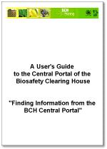 | There are several training modules available in PDF format, which provide a range of information from introductory material to in depth review. Most modules contain interactive exercises and detailed walk-through of the steps required for each activity. The following topics are addressed:
  MO01 | An Introduction To CPB
  MO02 | Introduction To BCH
  MO03 | Surfing the BCH Central Portal
  MO04 | Finding Information in the BCH
  MO05 | Recommended guidelines for Countries
  MO06 | Using the management Centre
  MO07 | Registering National Information
  MO08 | Registering sharing information
  MO10 | Information-sharing Obligations On Becoming a Party to the
   | Protocol

Interactive Modules
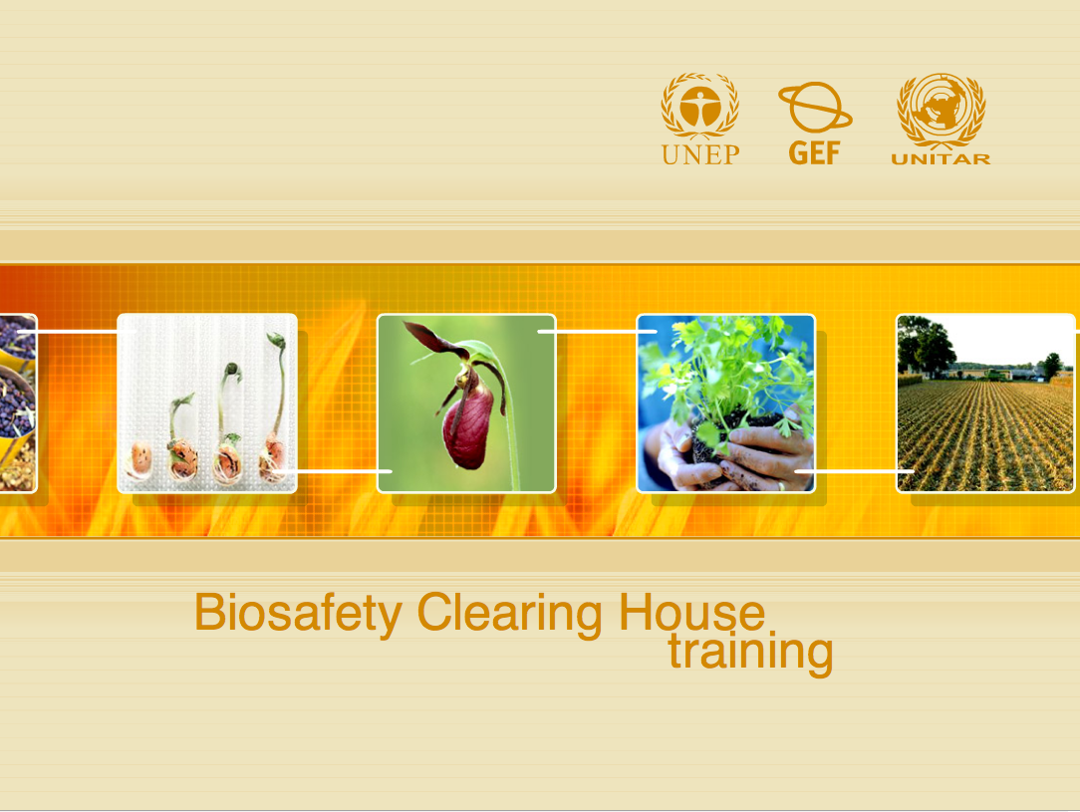 | There are two interactive training modules designed to enable users to understand the concepts introduced in Training Modules 1 and 2 in a hands-on manner. The modules are designed in Macromedia Flash  .
  IM01 | Introduction to the Cartagena Protocol on Biosafety
  IM02 | Introduction to the Biosafety Clearing House

Case Studies
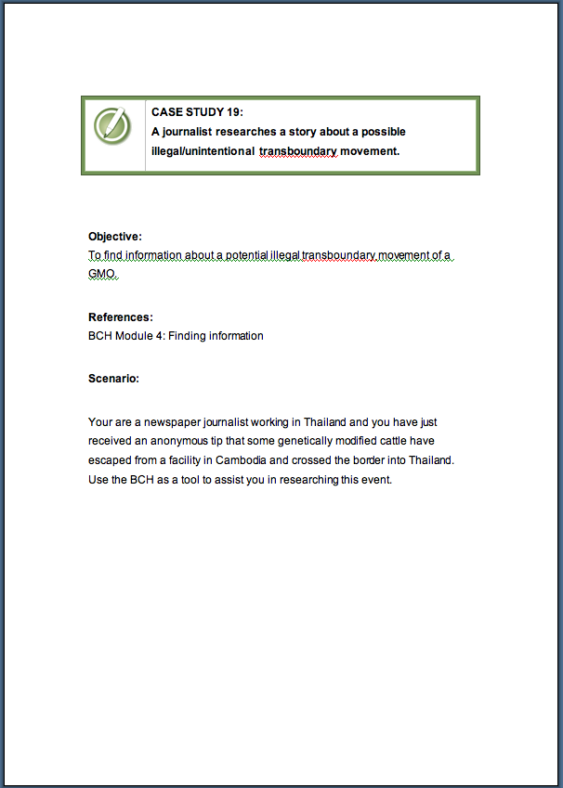 | There are several interactive case studies designed to assist users in applying the concepts covered in the various training modules
  CS01 | Mexican trader exporting cotton seed
  CS02 | Regulator researches LMO-FFPs
  CS03 | Registering data on CP - Users Management
  CS04 | Registering data on CP - contacts and CNA
  CS05 | Registering data on CP - LMOs and decisions on LMOs
  CS06 | Registering data on CP - Risk Assessment and Laws
  CS07 | Custom officer seeks information on importing LMOs
  CS08 | Scientist looks for info on commercially available GM cotton
  CS09 | Scientist seeks information on importing LMOs
  CS10 | Information CNA must provide to BCH about a decision
  CS11 | Medical researcher seeks info on AIA
  CS12 | Company rep seeks information on how submit record to BCH
  CS13 | National Development Agency seeks information on supporting
   | Capacity building programs.
  CS14 | Person seeks information on how to submit record to BCH
  CS15 | Person looks for info about a GM food product
  CS16 | Organization registers a contact person
  CS17 | Organization registers biosafety newsletter
  CS18 | Academic institution register biosafety course and workshop
  CS19 | Journalist researches story about possible illegal transboundary
   | movement
  CS20 | Country has just become a Party to the Cartagena Protocol
  CS21 | Regulator in Japan imports potatoes from ROK
  CS22 | Ghana risk assessment IR papaya
  CS23 | NFP registers biosafety expert
  CS24 | Inspector discovers illegal LMO
  CS25 | NFP registers decision and RA on GM cotton
  CS26 | NFP registers laws
  CS27 | Central Portal Information Route

Ready Reference Guide
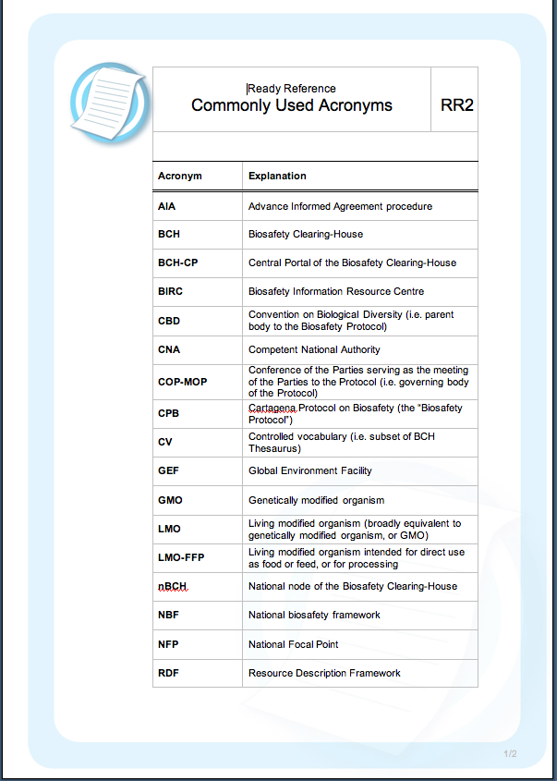 | There are several reference handouts available that provide quick overviews of frequently used parts of the BCH and may be used as desk references after training is complete. The following guides are available:
  RR01 | BCH Quick Start
  RR02 | Acronyms
  RR03 | BCH Record Types
  RR04 | Icons
  RR05 | Short glossary
  RR06 | Management Centre
  RR07 | Decisions and Declarations
  RR08 | Introduced Traits
  RR09 | Contacts
  RR10 | Information Resources
  RR11 | Unique identification
  RR12 | Information to be posted on the BCH
  RR13 | Timeframe for Posting Information
  RR14 | New Party Checklist

Discussion Points with Answer Keys
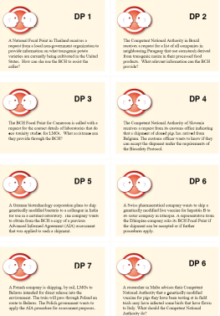 | There are several cards with different scenarios for discussion that can be used thought the training along with the answer keys

Quiz Questions with answer Keys
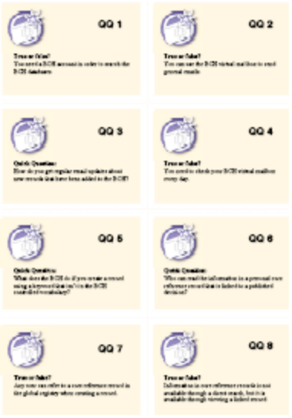 | There are several quiz questions available that provide quick interaction with participants and an easy way to gauge understanding of different uses of the BCH and may be used through the training

Operational Handbook
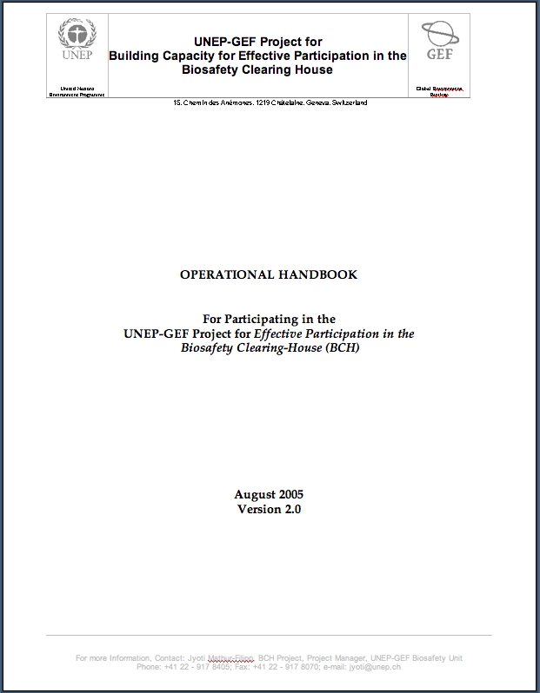 | The Operational Handbook provides detailed information for countries about participation in the UNEP-GEF Project for “Effective Participation in the Biosafety Clearing-House (BCH)

Promotional Material
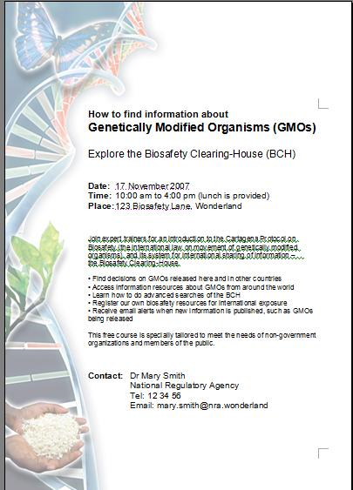 | Contains a one page poster and a short leaflet with basic content that can be customized by the country running the stakeholder courses and used as promotional materials

Exercises
There are several exercises for BCH training Workshop

Hermes BCH Development tool
Recently, SCBD has deployed a new application, code name HERMES, that can be used easily by countries willing to have their own simple national application, but do not have the resources to, or do not want to develop their own systems.

HERMES will run on SCBD servers, instantiated for each particular country. At the country level, it is just needed to have available computers with internet access and browsers. Customization is also performed via internet.

Ajax BCH Development tool
The BCH Ajax Plug-In is a lightweight JavaScript application based on Ajax technology that can be easily integrated to any website to allow dynamic display of information from the BCH Central Portal.

The use of the BCH Ajax Plug-In does not require any specific IT knowledge. The Plug-In works on all server platforms and does not require any software installation. All required files are located on the BCH Central Portal and maintained by the Secretariat.

The BCH Ajax Plug-In is a client side application. The connection to the BCH Central Portal is made directly by the client (end-user).

